1. Write a program that **inputs n integers and sums them up**.
   * The first line of the input holds the number of integers **n**.
   * Each of the following **n** lines holds an integer for summing.
   * Sum up the numbers and finally print the result.

**Sample input and output:**

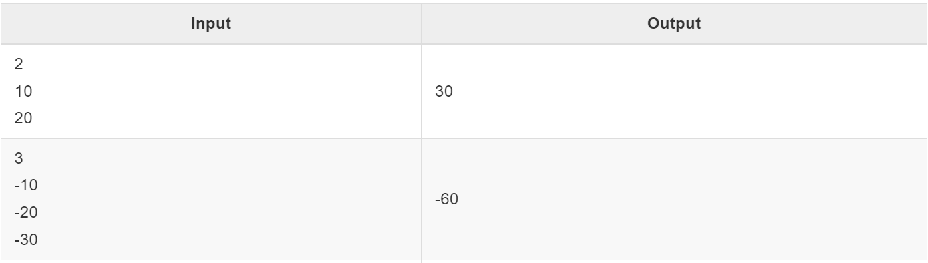

1. Write a program that gets your name and prints “Welcome” with your name and asks input “Do you want to continue”. If we provide “yes” then it needs to again ask your name or if we provide “no” then it must end the program.

**Sample input and output:**Enter your name: Ragunath

Welcome Ragunath  
Do you want to continue?

Yes

Enter your name: Ragunath

Welcome Ragunath  
Do you want to continue?

No

1. Write a Program that gets a number n from the user and prints all the multiples of 5 which are less than that number n.  
     
   **Sample input and output:**Enter a number: 10  
   Multiples of 5 are 5, 10
2. Write a program to generate the sum of n numbers.  
     
   **Sample input and output:**Enter a number: 5  
   Sum of number 5 is 15

1. Write a program to get a number and display the number with its reverse.  
     
   **Sample input and output:**Enter a Number: 123

Reverse of Entered Number: 321

1. Write a C# program to calculate the sum of different numbers entered by the user.  
     
   **Sample input and output:**Enter a number: 2   
   Enter a number : 2   
   Enter a number :2   
   Sum of given numbers is 6
2. Write a C# program to find the even numbers odd numbers and prime numbers in the range between 1- 100
3. Write a program to display the first n terms of Fibonacci series.  
     
   **Input** :   
   Input number of terms to display: 10   
     
   **Expected Output** :   
   Here is the Fibonacci series upto to 10 terms : 0 1 1 2 3 5 8 13 21 34
4. Using while loop print the numbers in range 1 to 10  
     
   **Output**: 1 2 3 4 5 6 7 8 9 10
5. Using while loop repeatedly get count of input and provide series of numbers in that count and find sum of square of given numbers.  
     
   **Input**:   
   count -5   
   number – 1 2 3 4 5   
     
   **Output**: 55